VIGNANA SOLUTIONS

MOBILE APP. FOR DR APPOINTMENT

Home Page

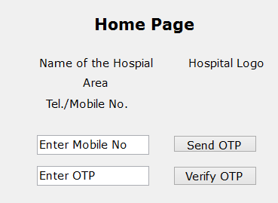

|  |  |  |  |
| --- | --- | --- | --- |
| **S.No** | **Field** | **Type** | **Requirement** |
|  | Name of the Hospital | Label | Should be attractive. As per the value supplied by Vignana |
|  | Area | Label | Should be attractive. As per the value supplied by Vignana |
|  | Tel/Mobile No | Label | Should be attractive. As per the value supplied by Vignana |
|  | Hospital Logo | Image | As per the image supplied by Vignana |
|  | Mobile No | Text box | Mandatory. Enabled. To accept only Number, 10 digits. |
|  | Send OTP | Button | Visible false. |
|  | Enter OTP | Text box | Password char. To accept 5 digit Number |
|  | Verify OTP | Button | Visible false. |

|  |  |  |
| --- | --- | --- |
| **Step** | **User Action** | **Mobile and HMS actions** |
| 1 | Opens the App | System verifies whether connectivity is available.   |  |  |  |  | | --- | --- | --- | --- | | **S.No** | **Case Description** | **Expected App action** | **Vignana** | | 1 | Connection Not available | Displays Alert message ‘Unable to connect to ‘+Hospital Name, Kindly contact ‘+Tel/Mobile No. |  | | 2 | Connection available | Seeks Hospital Info | Retrieves and gives back to Mobile app  Hospital Name, Logo, area, License validity, telephone info | | 3 | License is expired | Displays an error message ‘Mobile App expired, Kindly contact “+Tel/Mobile No |  | | 4 | License is active | Enables the Mobile No.  Set focus at Mobile |  | |
| 2 | Enters Mobile No. | |  |  |  |  | | --- | --- | --- | --- | | **S.No** | **Case Description** | **Expected App Action** | **Vignana** | | 1 | No. of Digits#10 | Display error message ‘Mobile No. should have 10 digits |  | | 2 | No. Digits=10 | * Generates 5 digits OTP * Sends to the given Mobile No. as SMS * Set ‘Send OTP’ button visible true * Set ‘Enter OTP’ label and text box visible true * Set focus at ‘Enter OTP’ |  | |
| 3 | Enters OTP | To execute ‘Verify OTP’ event after 5th digits is pressed |
| 4 | Clicks Verify OTP | |  |  |  |  | | --- | --- | --- | --- | | **S.No** | **Case Description** | **Expected App action** | **Vignana** | | 1 | When entered OTP # App Generated OTP | * Display an error message ‘Enter OTP is not correct’ * To Generate another OTP * Sends as SMS * Clear the wrong OTP * Set focus at OTP |  | | 2 | When entered OTP=App Generated OP | To Seek Mobile no. related information from Vignana | Retrieves records matching given mobile and gives back to Mobile app  Title, Name, Gender, Age w.r.to DoB, Status, Regn. No. | | 2a | When only one record is found and status is ‘Inactive’ | Display an error message ‘Inactive Member, Kindly contact ‘ +Hospital Tel/Mobile No |  | | 2b | When given mobile No. is not found | Open “New Registration” page |  | | 2c | When one or more than one record is available for the given mobile no. | Opens ‘Appointment’ Page with values |  | |

Appointment

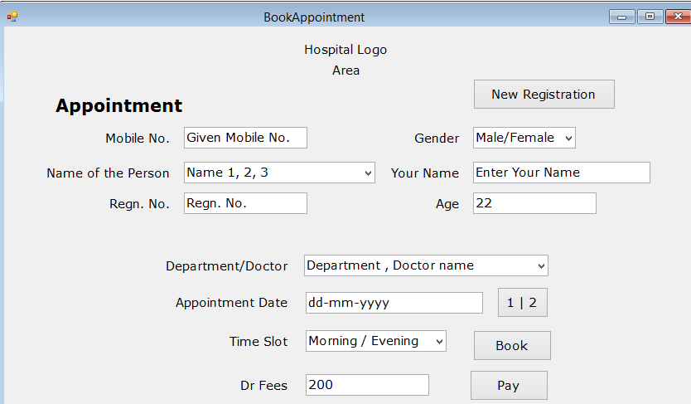

|  |  |  |  |
| --- | --- | --- | --- |
| **S.No** | **Field** | **Type** | **Requirement** |
|  | Hospital Logo | Image |  |
|  | Name of the Hospital | Label |  |
|  | Area | Label |  |
|  | Appointment | Label | Page caption |
|  | Mobile No | Text box | Read only as given by the user |
|  | Gender | Combo | Read only |
|  | Name of the Person | Combo box | Read only if only one record is found  Enabled. Mandatory if more than one record is found |
|  | Person Name | Text box | Read only. Name of the chosen person |
|  | Gender | Combo | Read only. Gender of the chosen person |
|  | Age | Text box | Read only. Age of the chosen person |
|  | Regn. No. | Text box | Read only. Regn. No of the chosen person |
|  | Department/Doctor | Combo | Enabled. Mandatory. To list department wise doctor names |
|  | Appointment Date | Text Box | Enabled. Mandatory. Format dd-mm-yyyy. User should be able to enter present or future date |
|  | Date Calendar | Date control | Enabled. User should be able to select present of a future date. |
|  | Time slot | Combo | Mandatory. User should be able to select a time slot |
|  | Dr Fee | Text box | Visible true if payment is to be accepted as per vignana  Visible false if payment is not needed as per vignana |
|  | Pay | Button | Visible true if payment is to be accepted  Visible false if payment is not needed |
|  | Book Appointment | Button | Optional. User should be able to Book Appointment by clicking. Visible only if payment is affected if payment is to be accepted. |
|  | New Registration | Button | To navigate to ‘New Registration’ page with values of Mobile No. Name and age should be empty |

|  |  |  |
| --- | --- | --- |
| **Step** | **User Action** | **Mobile and HMS actions** |
| 1 | Selects Names of the Patient, if more than one record is found | Refreshes Patient Name, Gender, Age and Regn. No  Set focus at Department / Doctor name |
| 2 | Selects a doctor by typing few chars of the department or doctor name |  |
| 3 | Enters Appointment date | Prompts server date, format dd-mm-yyyy. Not to accept past date.   |  |  |  |  | | --- | --- | --- | --- | | **S.No** | **Case Description** | **Expected App action** | **Vignana** | | 1 | Case when past date is given | Display an error message ‘’Past date is not accepted for booking appointment’ |  | | 2 | Case when proper date is given | Supplies doctor name and date to Vignana | Retrieves the timeslot(s) available for the doctor and date  Sends back to Mobile App | | 2a | Case when no time slot is available | To display an error message ‘Doctor is not available on ‘+ given date +’, Kindly contact ‘+Hospital Tel/Mobile No |  | |  |  |  |  | |
| 4 |  |  |
|  |  |  |

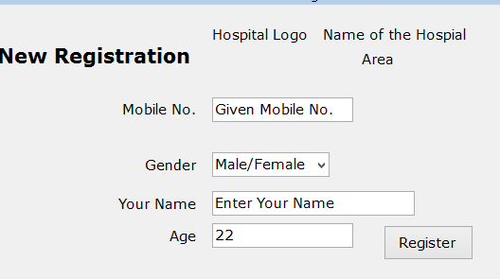

This page should be opened when given mobile No. is not found OR existing patient wants to register another member under the same mobile No., from Appointment Page.

|  |  |  |  |
| --- | --- | --- | --- |
| **S.No** | **Field** | **Type** | **Requirement** |
|  | Hospital Logo | Image |  |
|  | Name of the Hospital | Label |  |
|  | Area | Label |  |
|  | Mobile No | Text box | Read only as given by the user |
|  | Gender | Combo | Enabled. To Prompt ‘Male’, Possible values Male and Female |
|  | Name | Text box | To prompt blank. Enabled. Mandatory. Max 50 chars |
|  | Age | Text box | Mandatory. Enabled to accept integer from 1 to 150, Format 999 |
|  | Register | Button | Enabled. |

|  |  |  |
| --- | --- | --- |
| **Step** | **User Action** | **Mobile and HMS actions** |
| 1 | Selects Gender |  |
| 2 | Enters Name |  |
| 3 | Enters Age |  |
| 4 | Clicks Register | |  |  |  |  | | --- | --- | --- | --- | | **S.No** | **Case Description** | **Expected App Action** | **Vignana** | | 1 | No Name is given | Display an error message ‘Kindly enter the name of the patient’ |  | | 2 | No age is given or given age is not between 1 and 150 | Display an error message ‘Kindly enter Age between 1 and 150’ |  | | 3 | Otherwise when correct values are given | Supplies all the information to Vignana | Checks for duplication of mobile No. and given name  If duplicate is found  Sends duplication message  Else  Inserts record  Sends Registration No | | 3a | When duplication is informed by Vignana | Displays an error message ‘Duplication of given mobile no. and name, kindly give another name or exit’ |  | | 3b | When new registration is done successfully by Vignana | Displays and Sends SMS to Mobile No. with text ‘Thanks for registering through Mobile App.with us, Your Registration No. is ‘+ value given by vignana  Close this New Registration page  Opens Appointment Page |  | |